**Contents**

**INTRODUCTION** 1

**TEAM MEMBERS** 2

**ROLES** 2

**GANTT CHART** 3

**GLIMPSE ABOUT APP** 4

**What is Agile Methodology?** 4

**PAGES AND SCREENSHOTS** 5

HOME PAGE 5

Category Sections Page 5

Product Sections Page 6

Other Screenshots 7

## **INTRODUCTION**

The main aim of this project is the design of an agile / scrum mobile application named Dentapp. It is record keeping app which is used for having all records of any visit and documentation.

# **TEAM MEMBERS**

1.Khushdeep Singh

2.Navpreet Kaur

3.Navpreet Singh

4.Harpreet Kaur

5.Sumanpreet Kaur

## **ROLES**

Khushdeep Singh : Owner

Navpreet kaur: Scrum Master

Navpreet Singh: Front End Developer

Harpreet kaur: Stakeholder

Sumanpreet kaur: Back End Developer

## **GANTT CHART**

|  |  |  |  |  |  |  |  |  |  |  |  |  |  |  |  |
| --- | --- | --- | --- | --- | --- | --- | --- | --- | --- | --- | --- | --- | --- | --- | --- |
| **Stages** | **Activities** | **Duration**  **Week1-2** | | | | **Duration**  **Week-2-3** | | | | | **Duration**  **Week-3-4** | | | | |
| Project Planning | Research |  |  |  |  |  |  |  |  |  |  |  |  |  |  |
| Start of Meeting |  |  |  |  |  |  |  |  |  |  |  |  |  |  |
| Project Proposal and documentation |  |  |  |  |  |  |  |  |  |  |  |  |  |  |
| Project Execution | Application Design |  |  |  |  |  |  |  |  |  |  |  |  |  |  |
| UI Design |  |  |  |  |  |  |  |  |  |  |  |  |  |  |
| coding |  |  |  |  |  |  |  |  |  |  |  |  |  |  |
| Testing |  |  |  |  |  |  |  |  |  |  |  |  |  |  |
| Final | Documentation and Report |  |  |  |  |  |  |  |  |  |  |  |  |  |  |

0 1 2 3 4

## **GLIMPSE ABOUT APP**

This app is a Dental app which is used for having all records of any visit, whatever their problems, which doctor and which surgery they want. . Moreover, there are dates included.

It took about 4 weeks to complete the application.

This app has three sections:

1.Visits Section

2.Documentation Section

3. compendium of knowledge.

## **What is Agile Methodology?**

The Agile methodology is used in this project as an alternative to traditional approaches. This strategic approach is highly effective and pragmatic and addresses technology's changing needs.

Our group used the agile / scrum method in this project. The team members originally identify and follow all requirements. The team then decided to implement the Dentapp App to satisfy users ' needs.

There have been many changes to make this software more user-friendly. The app is available for customers after all updates have been created.

## **PAGES AND SCREENSHOTS**

## HOME PAGE

This is the main page of the application. On this page there are three buttons Visits Section, Documentation Section and compendium of knowledge Section. With the help of this page, the user can select the option as per their choice.

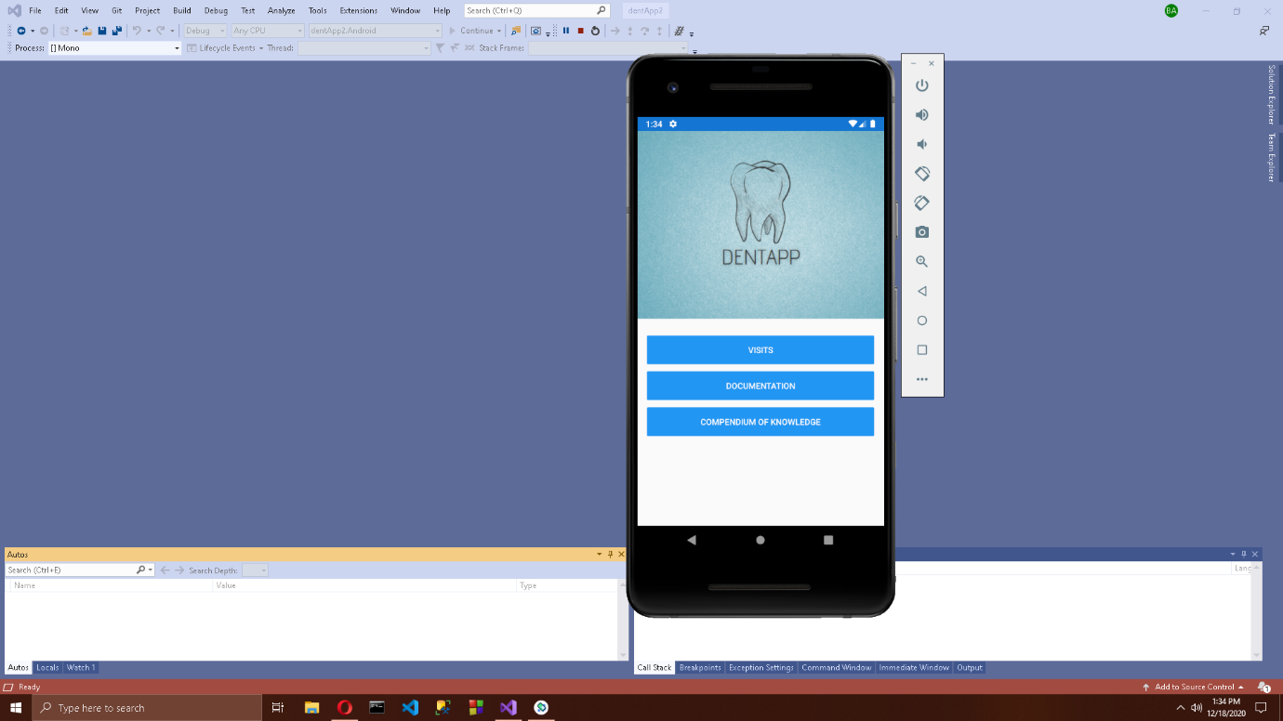

## Category Sections Page

In this page, there are two buttons named as Toothache and Whitening.

## Sections Page

In this page, there are also three buttons named as Visits, Documentation and compendium of knowledge.



## Other Screenshots

